Cheedo

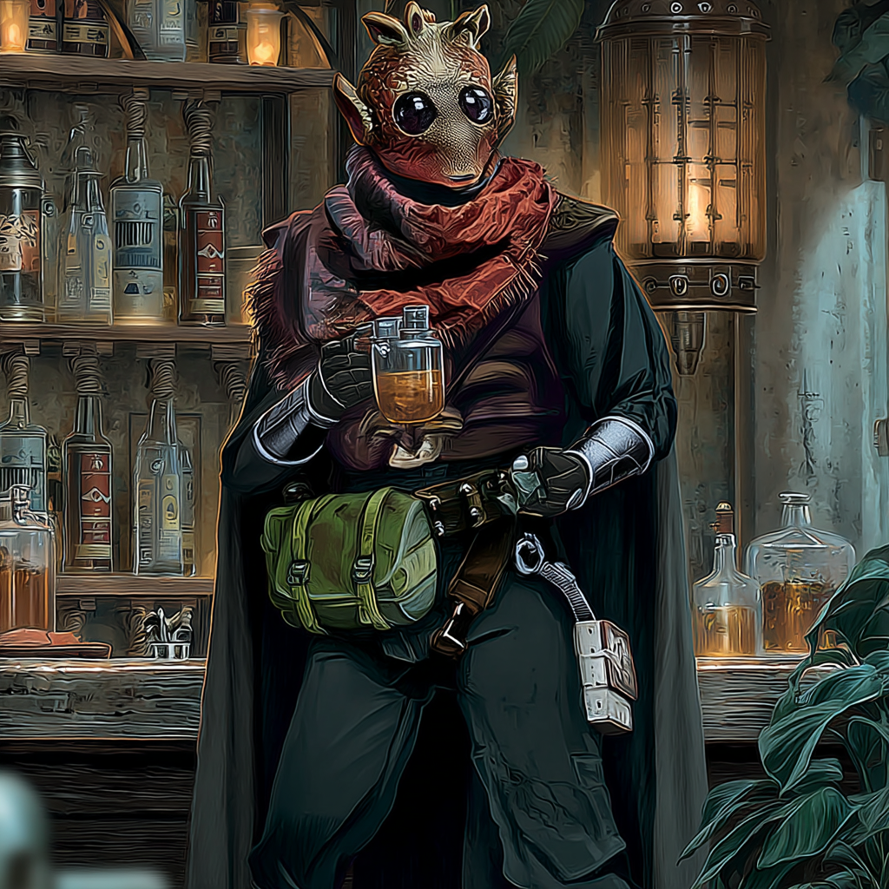
The shooting range on Rodia had seventeen competition levels. Cheedo won sixteen of them before his fifteenth birthday. The seventeenth was for adults only. He won that at sixteen by lying about his age. The trophy was worthless metal. The reputation was worth everything.
Competition shooting was clean. Targets did not bleed. Nobody screamed. Points were tallied. Winners were announced. Everyone went home. Cheedo's uncle watched him win that adult competition and saw credit signs. A nephew who could thread shots through closing blast doors was wasted on trophies.
"One job," his uncle said. "Protection for a cargo run. Nothing violent. Just insurance."
The cargo was spice. The protection became necessary when rival smugglers tried to take it. Cheedo put three shots through a viewport at range that should have been impossible. The rivals reconsidered. The cargo stayed secure. His uncle paid him more than a year of competition prizes.
One job became five. Five became a pattern. Competition shooting did not pay for his mother's medical treatments. Competition shooting did not keep his younger siblings fed. Real shooting did both.
He learned the differences quickly. Real targets moved unpredictably. Real shooting happened in bad light with worse positions. Real consequences lasted longer than point tallies. But the fundamentals were identical. Breathing. Timing. Patience. Squeeze, do not pull.
For three years he flew gunner positions for independent crews. Never for the Empire. Never for slavers. Sometimes for smugglers who moved harmless contraband. Sometimes for merchants who needed protection. Always for credits that went home to Rodia.
The mistake happened in a cantina on Tatooine. Local crew. Friendly drinks. Someone asked about his best shot. Cheedo had consumed too much Corellian whiskey. He told the truth. Three shots through a closing blast door while the ship was maneuvering. All three hit the same target. Different points on the body. Disabling, not killing. Harder than a kill shot. More impressive.
The crew was impressed. So was the Imperial informant two tables over.
The bounty appeared within six hours. Armed and dangerous. Confirmed multiple kills. Shoot on sight authorization. None of it was true except the armed part. Cheedo always went armed. Rodia taught that lesson early.
He ran. Changed ships at every port. Paid bribes that drained his savings. The bounty followed. Updated with new false crimes. The number kept rising. Someone wanted him dead and was willing to pay well for it.
His comm buzzed at a fuel depot. Unknown frequency. Text only: "North hangar. Bay seven. Y-wing. Pilot named Dakk needs gunner. You need wings. Kestrel makes problems disappear."
Cheedo went carefully. The Y-wing was military surplus. Worn but maintained. The pilot stood beside it. Human. Young. Eyes that measured distances without thinking. Pilot's eyes.
"You the shooter who talks too much?" Dakk asked.
"Used to be."
"Can you still shoot?"
"Better than whoever you have now."
"Position is empty. I fly. You shoot. We split earnings. Kestrel handles contracts."
"What kind of contracts?"
"The kind where shooting matters more than talking."
They shook hands. No contracts. No promises beyond the next job. Trust would come later or it would not. For now, they had an arrangement.
Kestrel made the bounty disappear within a week. The rival who posted it suddenly had their accounts frozen. Their tip line went dead. Their own bounty appeared for unrelated crimes that might have been real. The hunter who had taken the job found more profitable targets. Cheedo's name dropped off priority lists.
He owed Kestrel now. The jobs were payment. Escort duty for freighters carrying supplies to people the Empire wanted to starve. Interdiction runs against corporate enforcement squads. Distraction plays that drew Imperial attention away from Rebel operations. Always careful. Always calculated. Always with Dakk flying patterns that made shooting possible.
They developed a rhythm. Dakk trusted Cheedo to make impossible shots. Cheedo trusted Dakk to give him the angles. Neither talked much. Both preferred it that way. The Y-wing became home. The cockpit became comfortable. The work became routine.
Cheedo sent credits home when he could. His mother's treatments continued. His siblings stayed in school. Nobody asked where the money originated. Rodia understood that sometimes credits came from directions you did not examine closely.
The courier mission briefing was sparse. Specific timing windows. Disable escorts without destroying them. Extract team needed cover. Precision required. Kestrel's payment offer was comprehensive: permanent retirement of all outstanding markers. Every debt. Every favor owed. Every connection to his past that might resurface.
Cheedo cleaned his weapons while Dakk ran pre-flight checks. The targeting array was calibrated to his preferences. The ammunition was sorted by purpose. Anti-shield rounds. Armor penetrators. Ion charges for disabling. Everything had its place. Everything had its purpose.
He thought about the shooting range on Rodia. Clean targets. Clear scoring. Simple winner and loser. This mission would be nothing like that. Real violence. Real consequences. Real people who would die if he missed.
But the fundamentals remained. Breathing. Timing. Patience. Squeeze, do not pull. Whether the target was paper or titanium. Whether the range was measured or estimated. Whether the stakes were trophies or lives. The fundamentals remained.
Dakk looked back from the pilot's seat. "You ready?"
"Always ready."
"Nervous?"
"Always nervous. Nervous keeps you sharp."
"Good. Overconfident gunners get pilots killed."
Cheedo nodded. Another fundamental: respect the weapon, respect the target, respect the consequences. Competition shooting had taught him the first two. Real shooting had taught him the third.
The Y-wing would fly into combat soon. Dakk would give him angles. Cheedo would make shots. Some would be impossible. He would make them anyway. That was his job. That was his value. That was why Kestrel had saved him from the bounty.
Everyone owed someone something. Cheedo owed Kestrel his life. After this mission, that debt would be paid. Then he could choose his shots for his own reasons. Help who he wanted. Hurt who deserved it.
But first, he had to thread needles with plasma bolts while flying at speeds that turned physics into suggestions. He had to disable without destroying. He had to protect without killing unless killing became necessary.
He checked his weapons again. Clean. Calibrated. Ready.
So was he.

